Batch: 3 Roll No.: 16010123012

Experiment / Assignment / Tutorial No. 03

Title: Implementation of Decision Tree

Aim: To understand & implement Decision Tree using python.
Expected Outcome of Experiment:
CO2: Apply supervised learning techniques to analyse and evaluate real-world applications.
Books/ Journals/ Websites referred:
1. “Machine Learning”, Tom M. Mitchell, McGraw Hill, 2017.
2. https://www.geeksforgeeks.org/machine-learning/decision-tree-introduction-example/
3. https://medium.com/@abhishekjainindore24/all-about-decision-trees-80ea55e37fef

Theory of Decision Tree:
Decision trees provide a structured framework for making decisions by visually mapping out the potential outcomes and choices involved in a decision-making process. Decision trees are particularly useful when dealing with complex and uncertain situations, allowing decision-makers to weigh the pros and cons of different options systematically.

Steps to perform a decision tree analysis:
Step 1: Identify the problem
Identify the goals and objectives, as well as the key variables and factors that will influence the decision. This step lays the foundation for the entire analysis.

Step 2: Begin to structure the decision tree
Once the problem is well-defined, the next step is to begin creating the decision tree. The tree starts with a decision node from which branches extend, representing different options. Further nodes are added to represent the potential outcomes of those options.

Step 3: Identify decision alternatives
Continue building out the decision tree by listing all possible alternatives or courses of action available. Add these as branches stemming from the central decision node.
These alternatives represent the different paths or choices that can be taken in the decision-making process.

Step 4: Estimate payoffs or costs
Assign payoffs or costs to each outcome. These values represent the impact or consequences of each outcome on the overall decision. Consider both quantitative and qualitative factors when estimating payoffs or costs.

Step 5: Assign probabilities
Assigning probabilities to each potential outcome is crucial. These probabilities can be derived from historical data, market research, or expert judgment. They represent the likelihood of each outcome occurring, providing a quantitative basis for your decision-making process.

Step 6: Determine the potential outcomes
Each outcome has a value attached to it. This could be the potential financial gain or loss, the impact on customers, or any other metric that matters to your decision. These outcomes should cover both positive and negative aspects, as well as any uncertainties and risks involved. Multiply each outcome value by its probability to calculate the expected value of each decision path.

Step 7: Analyze and select the best decision
By adding up the expected values of each decision path, identify the most promising option. This decision point provides the highest expected value, giving you a data-driven recommendation for your strategic decision.

Step 8: Review and update the decision tree
As new information becomes available or circumstances change, decision tree should evolve. Perform a sensitivity analysis at this stage by testing key assumptions, probabilities, or payoffs. This step helps identify the robustness of the chosen decision and provides insights into potential areas of uncertainty or risk.

Problem Definition:
Apply Decision Tree on housing or diabetes dataset or any other dataset and evaluate the performance of Decision Tree on various parameters like Accuracy, Precision, Recall, and F1.
Details of data set used:
https://drive.google.com/file/d/1YPi2IVlZxqoSyFdaxHvMGi56GIJ6YAKc/view?usp=sharing
API/Function used:
- read_csv()
- train_test_split()
- DecisionTreeClassifier()
- fit()
- predict()
- accuracy_score()
- precision_score()
- recall_score()
- f1_score()
- confusion_matrix()
- classification_report()

Results:
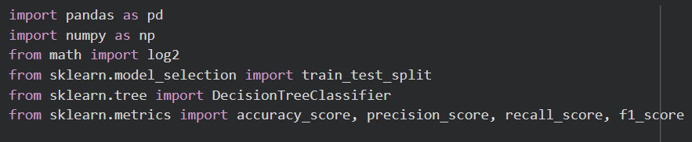
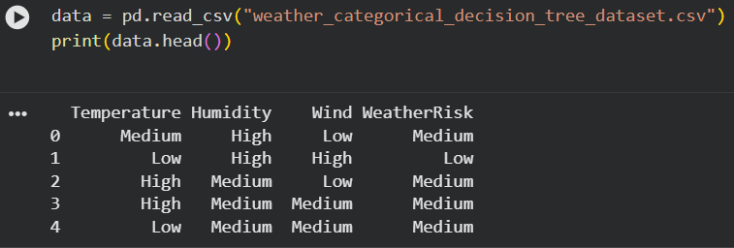
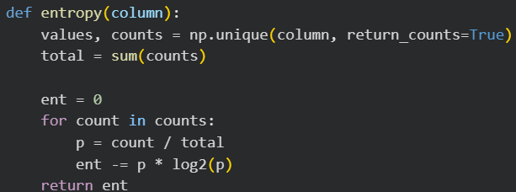
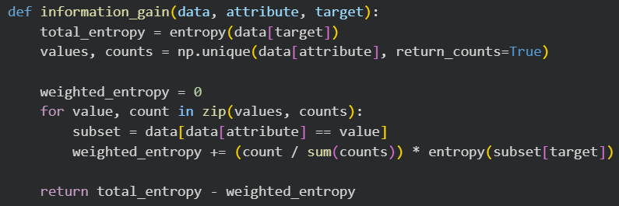
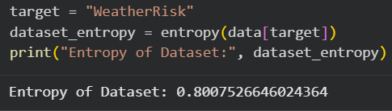
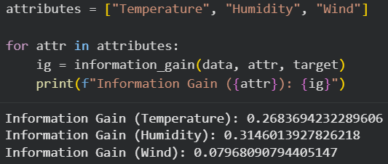
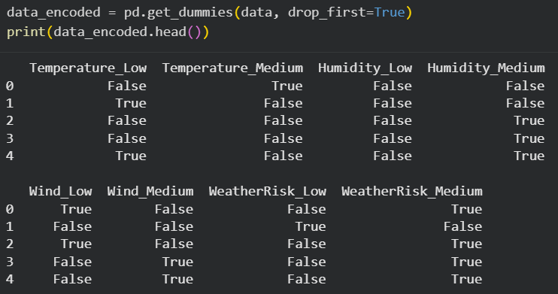
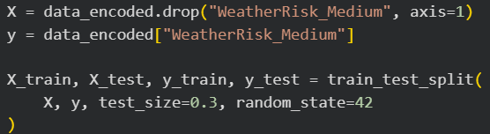
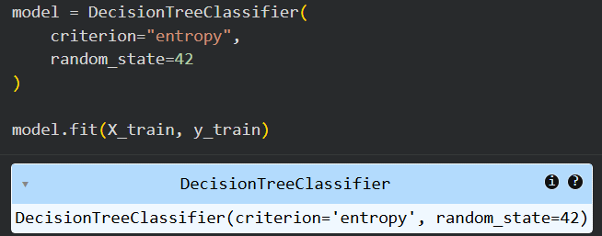

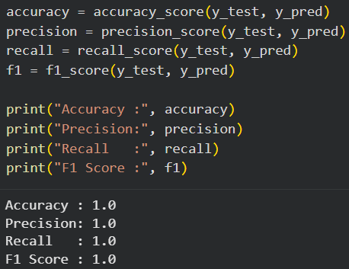
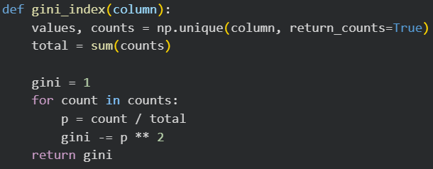
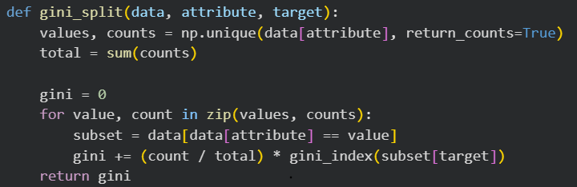
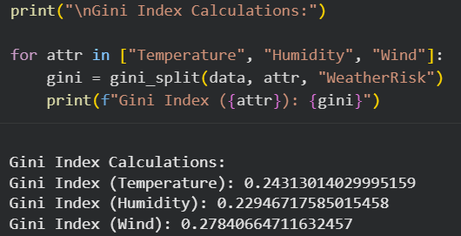
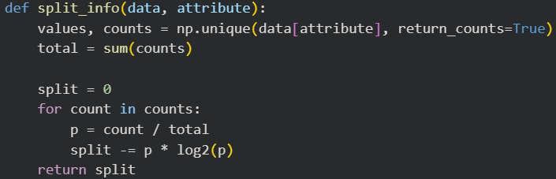
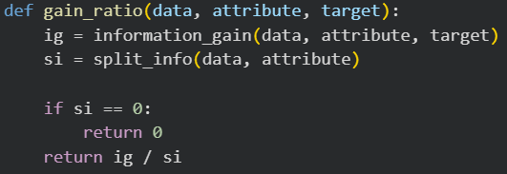
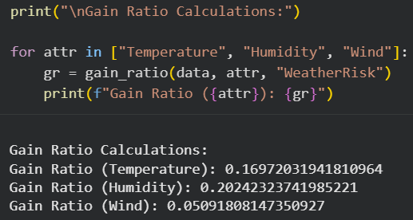

Conclusion:
In this experiment, we implemented a Decision Tree model using Python and evaluated its performance using Accuracy, Precision, Recall, and F1-score. Entropy and Information Gain helped the model decide the best way to split the data. The results showed that Decision Trees are simple yet powerful for solving classification problems and can effectively analyse real-world datasets in an understandable way.

Post Lab:

- Construct Decision Tree for the given Dataset and show the calculation of Entropy and Information Gain for every possibility.

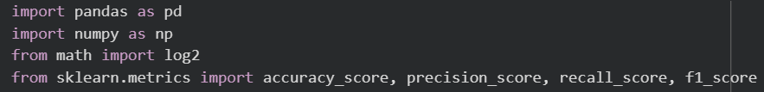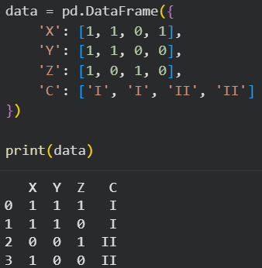
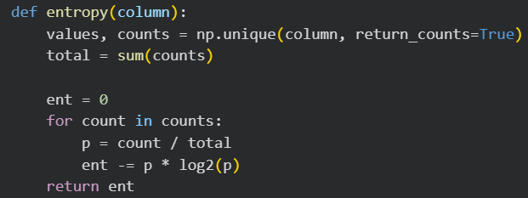
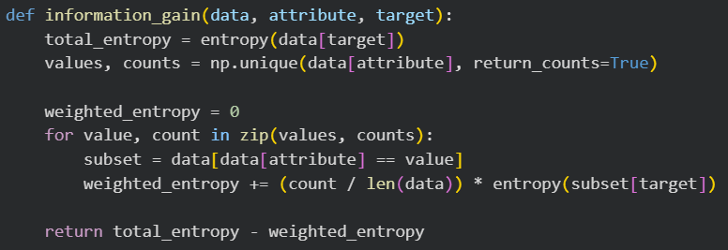
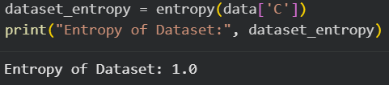
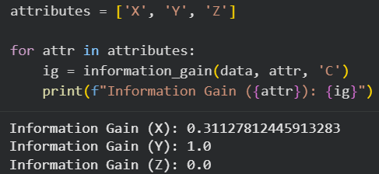
2. Calculate Accuracy, Precision, Recall, and F1.
